Ross Bollinger

Dr. M. Owrang

25 April 2019

CSC 434

Theatre Database Web Application Outputs

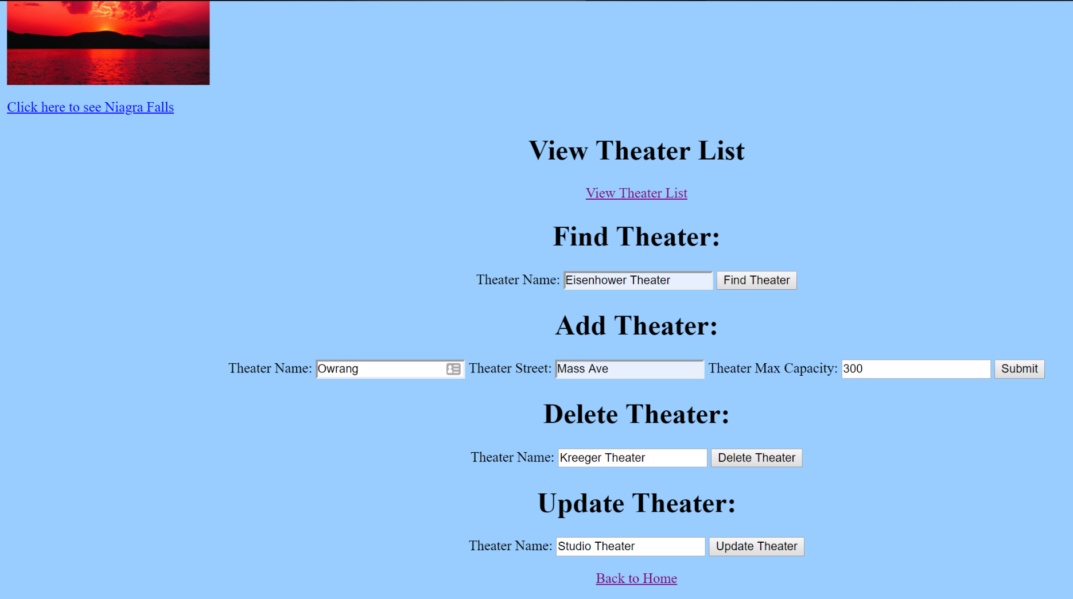Entire Website with all info entered for operations on the database:

**View Theater List Ouput:**

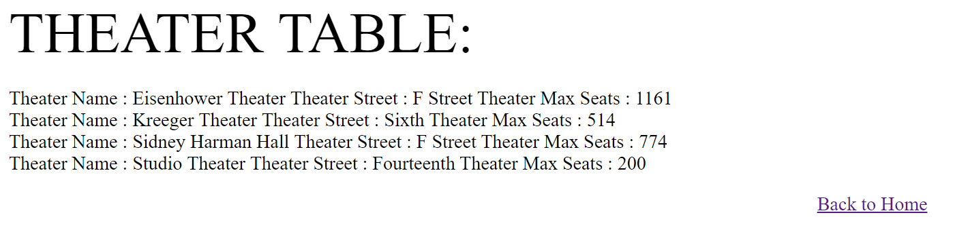

**Find Theater Output:**

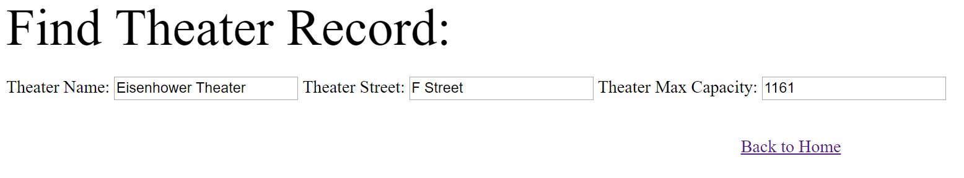

**Add Theater Output (adding Owrang):**

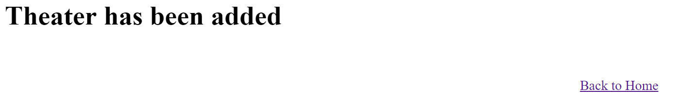

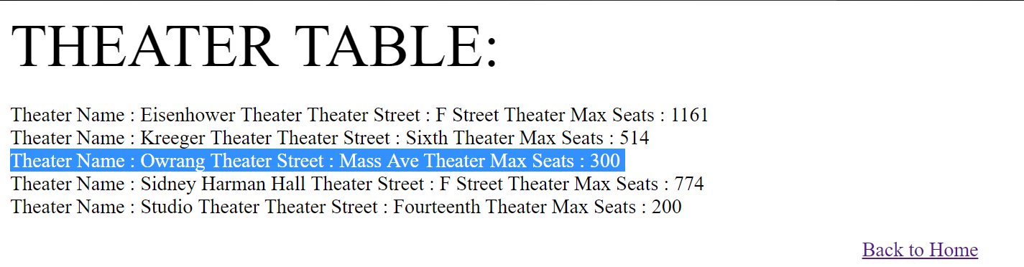

**Delete Theater Output (deleting Kreeger Theater):**

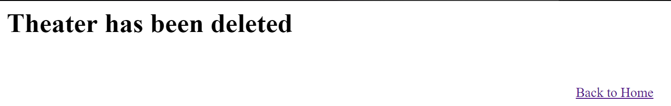

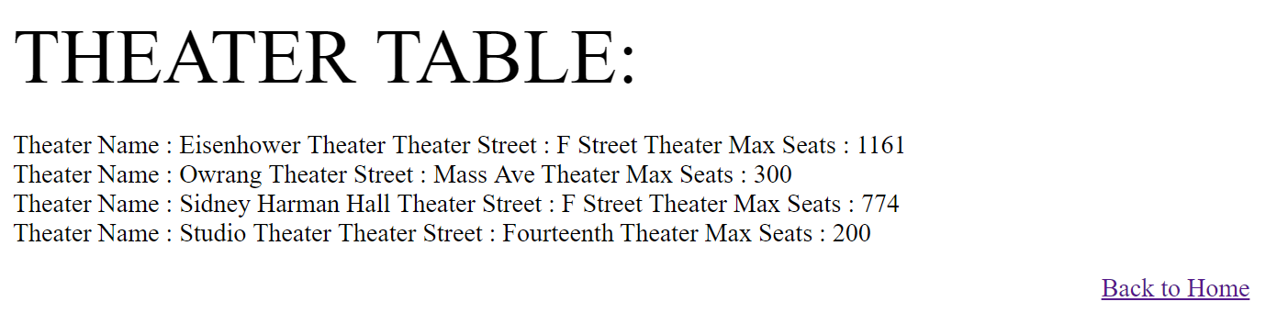

**Update Theater Output (updating street name for Studio Theater):**

